**Database Administration Homework**

**PART 1**

**1. Download MySQL server for your OS on VM.**

**2. Install MySQL server on VM.**

I am going to use AWS EC2 instance.

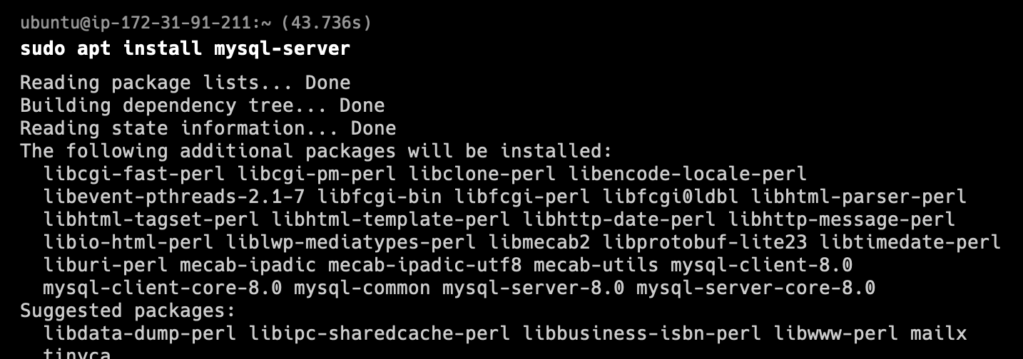

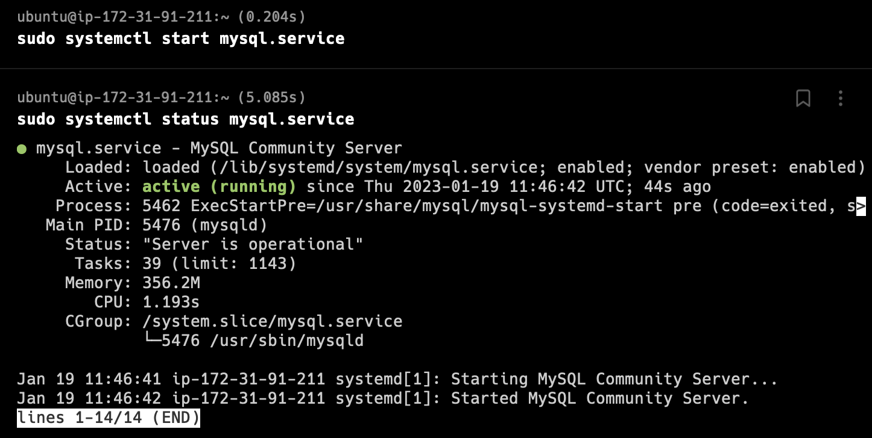

**3. Select a subject area and describe the database schema, (minimum 3 tables)**

Subject area: Online Shopping

Table 1: Users

* UserID (Primary Key)
* Name
* Email
* Password
* ShippingAddress

Table 2: Products

* ProductID (Primary Key)
* Name
* Description
* Price
* Quantity

Table 3: Orders

* OrderID (Primary Key)
* UserID (Foreign Key referencing Users table)
* ProductID (Foreign Key referencing Products table)
* Quantity
* TotalPrice
* OrderDate

**4. Create a database on the server through the console.**

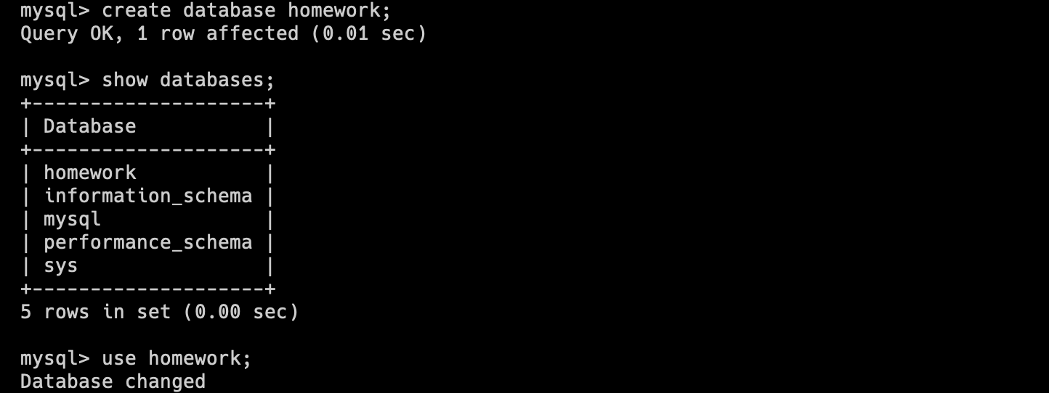

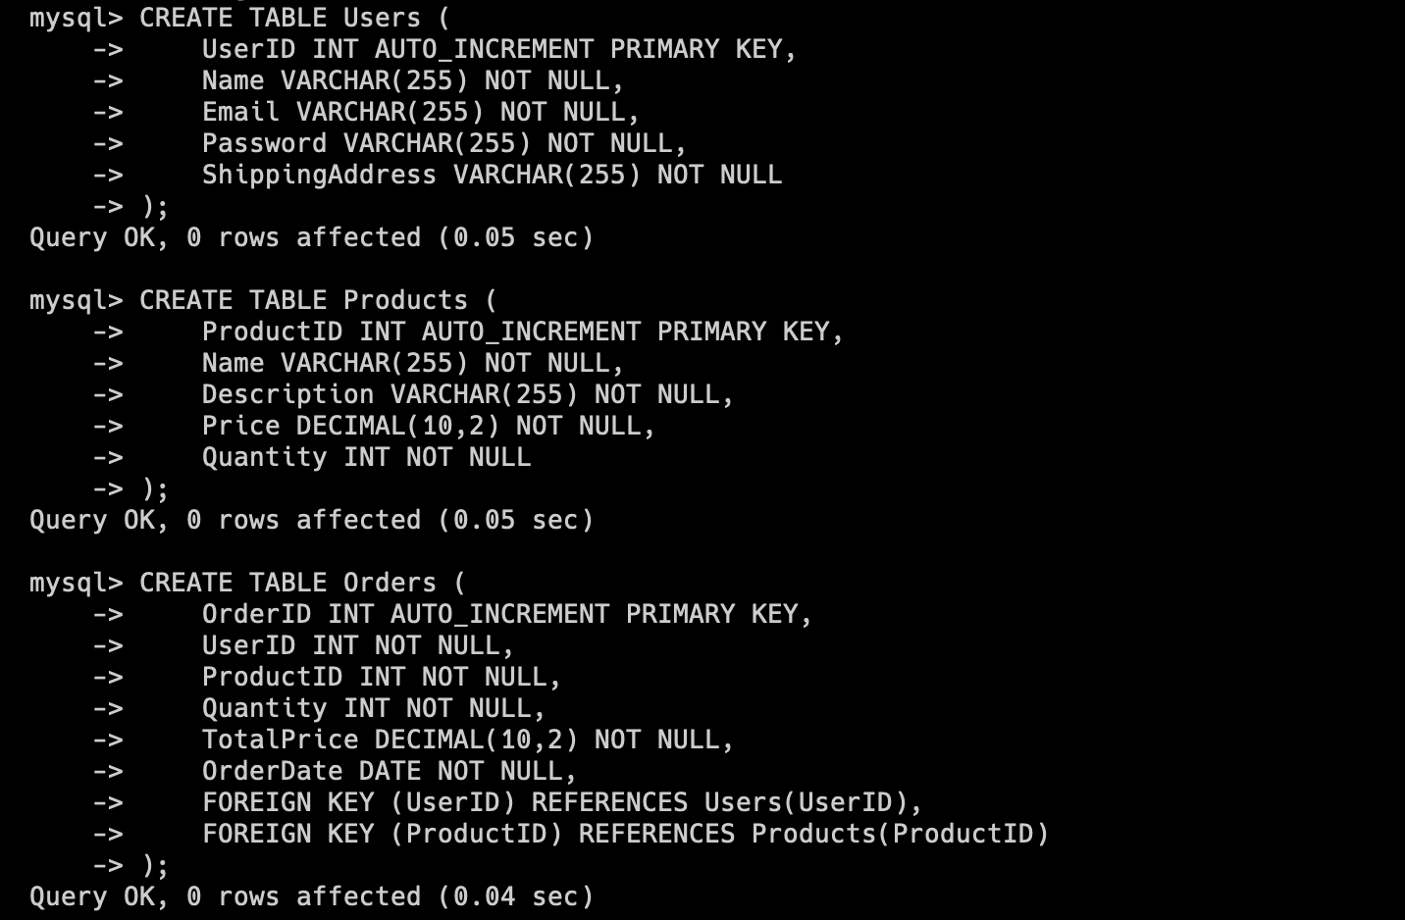

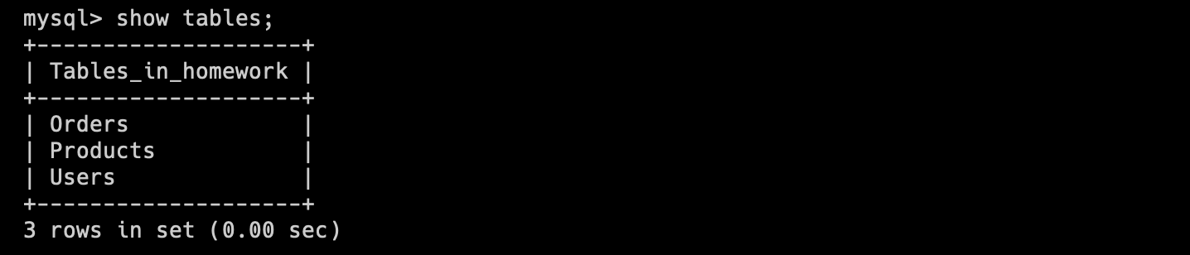

**5. Fill in tables.**

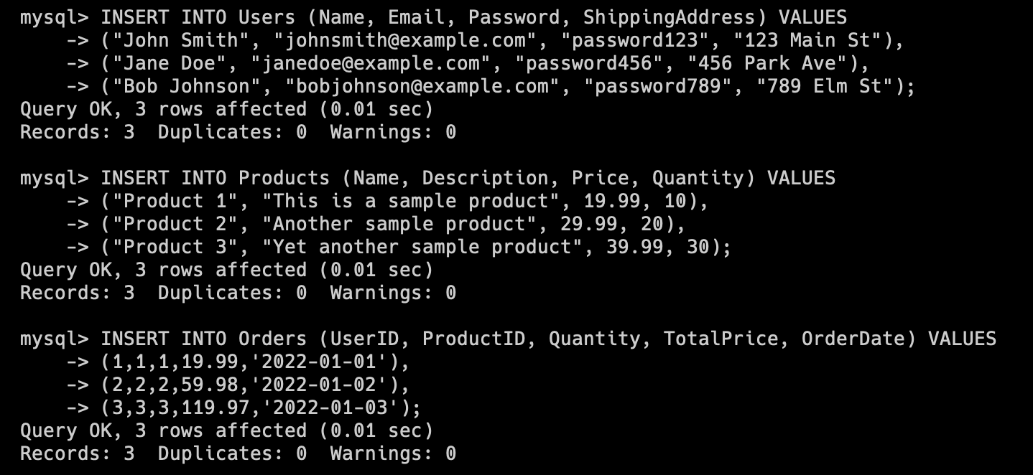

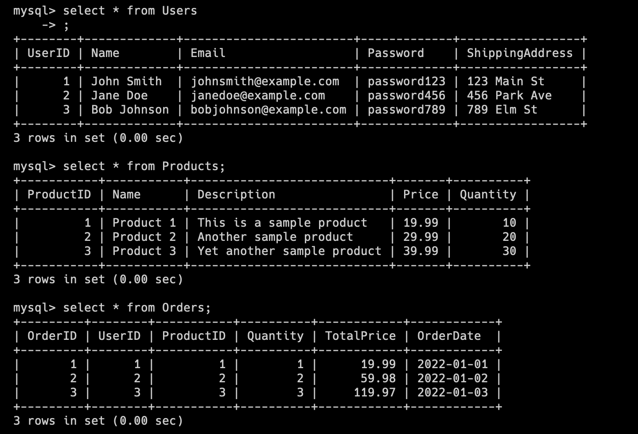

**6. Construct and execute SELECT operator with WHERE, GROUP BY and ORDER BY.**

- Retrieve all the orders placed by a user with a specific email address, ordered by the order date:

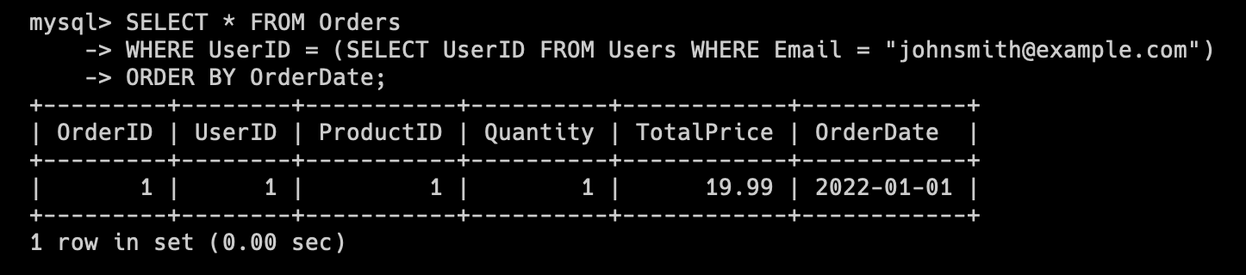

* Retrieve the total quantity and total price of products sold for each product:

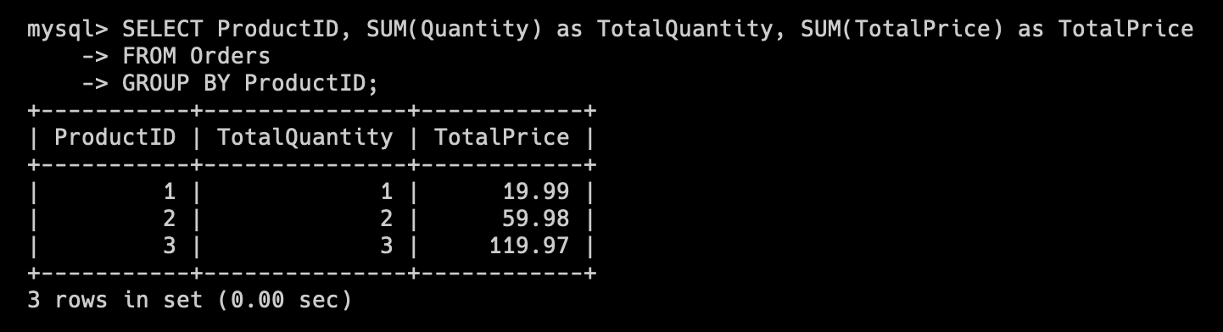

* Retrieve the total price of orders for each user, ordered by the total price in descending order:

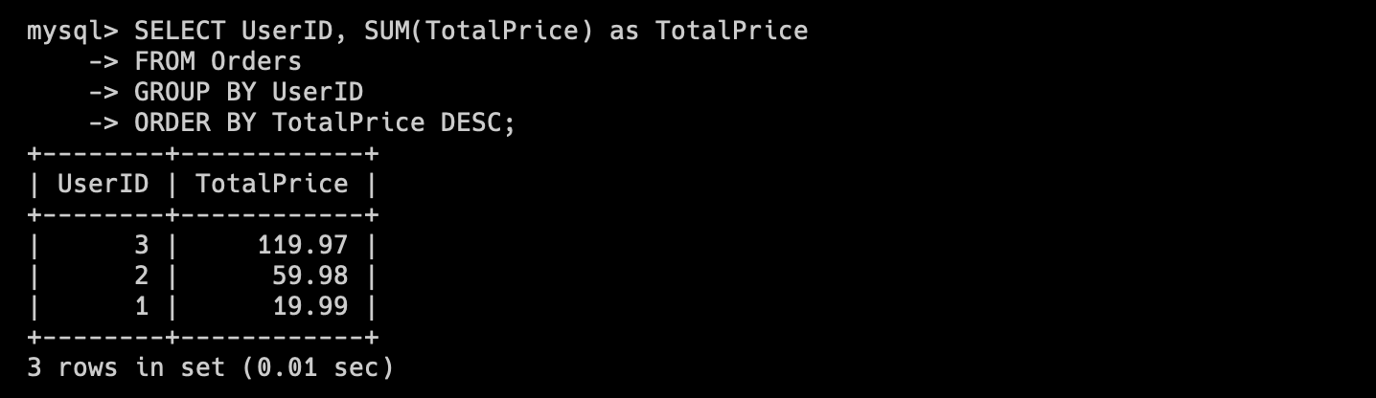

**7. Execute other different SQL queries DDL, DML, DCL.**

1) DDL (Data Definition Language)

- CREATE TABLE: Creates a new table in the database.

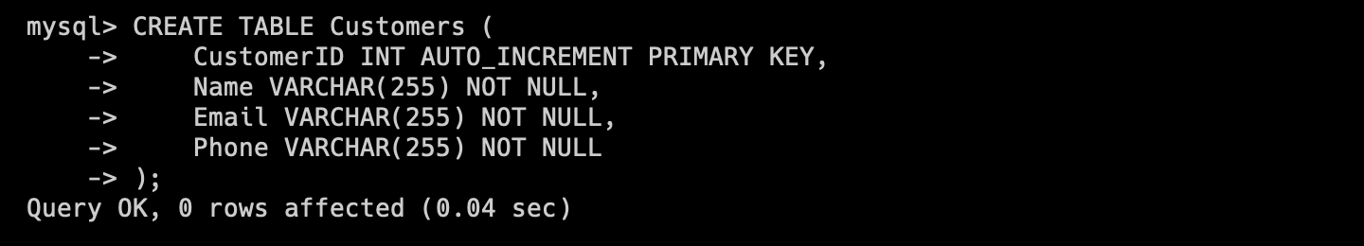

- ALTER TABLE: Modifies an existing table in the database.

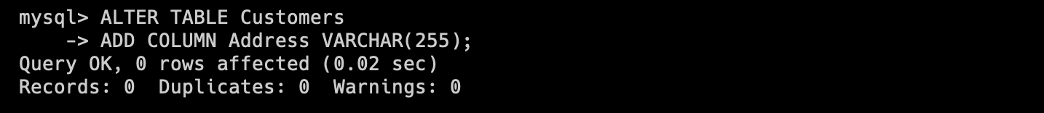

- DROP TABLE: Deletes an existing table in the database.



2) DML (Data Manipulation Language)

- INSERT INTO: Inserts new data into a table in the database.

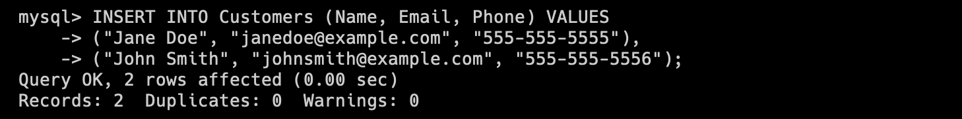

- SELECT: Retrieves data from one or more tables in the database.

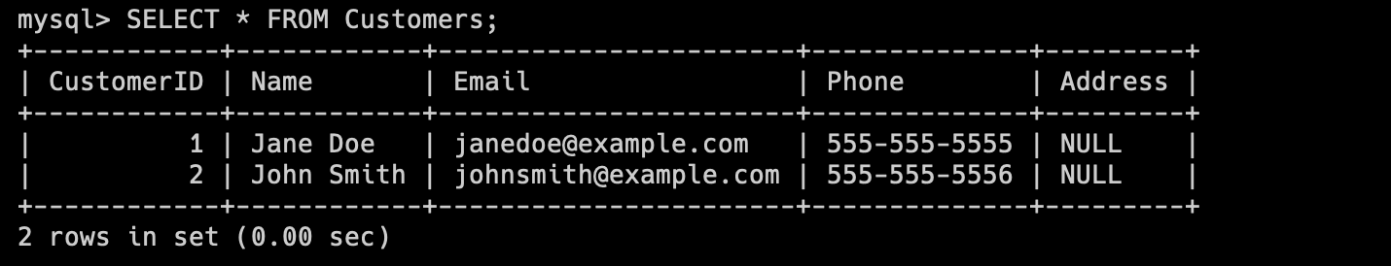

- UPDATE: Modifies existing data in a table in the database.

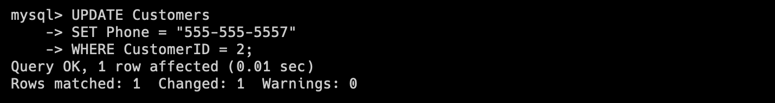

- DELETE FROM: Deletes data from a table in the database.

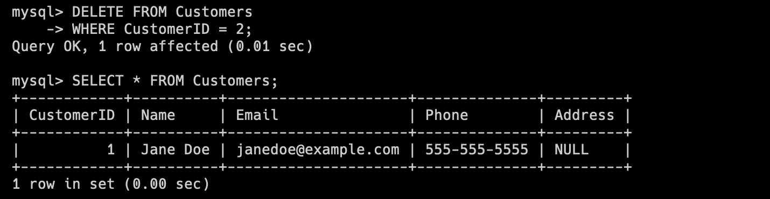

3) DCL (Data Control Language)

- GRANT: Gives a user permission to perform a specific action.

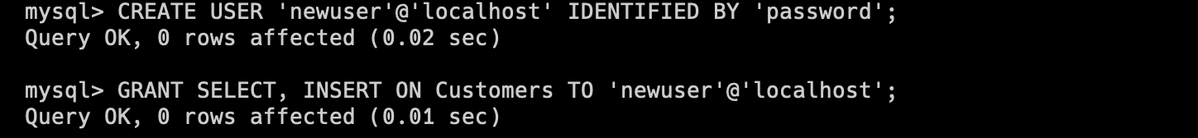

- REVOKE: Removes a user's permission to perform a specific action.



**8. Create a database of new users with different privileges. Connect to the**

**database as a new user and verify that the privileges allow or deny certain**

**actions.**

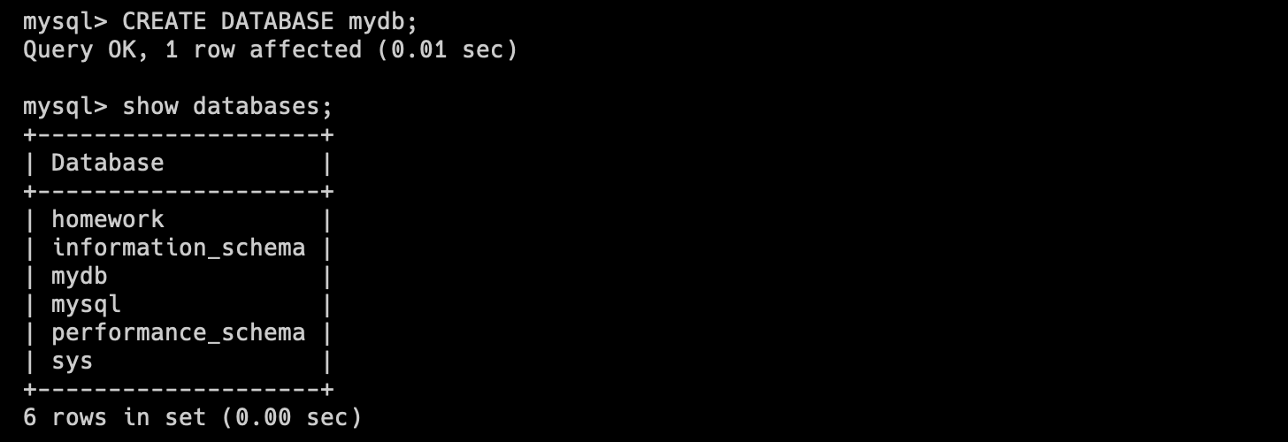

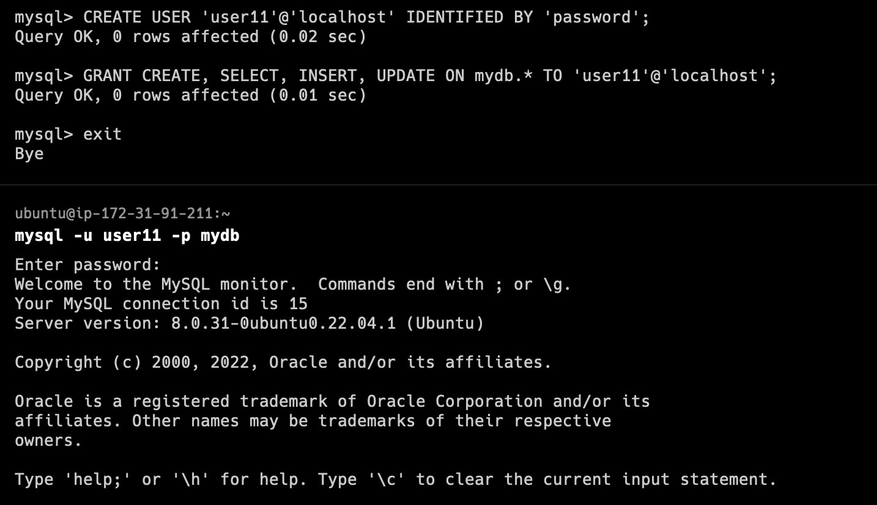

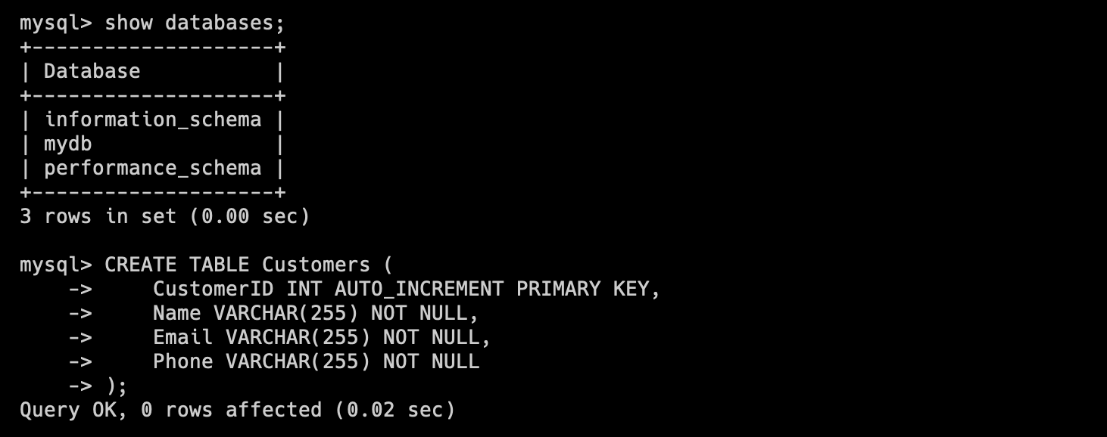

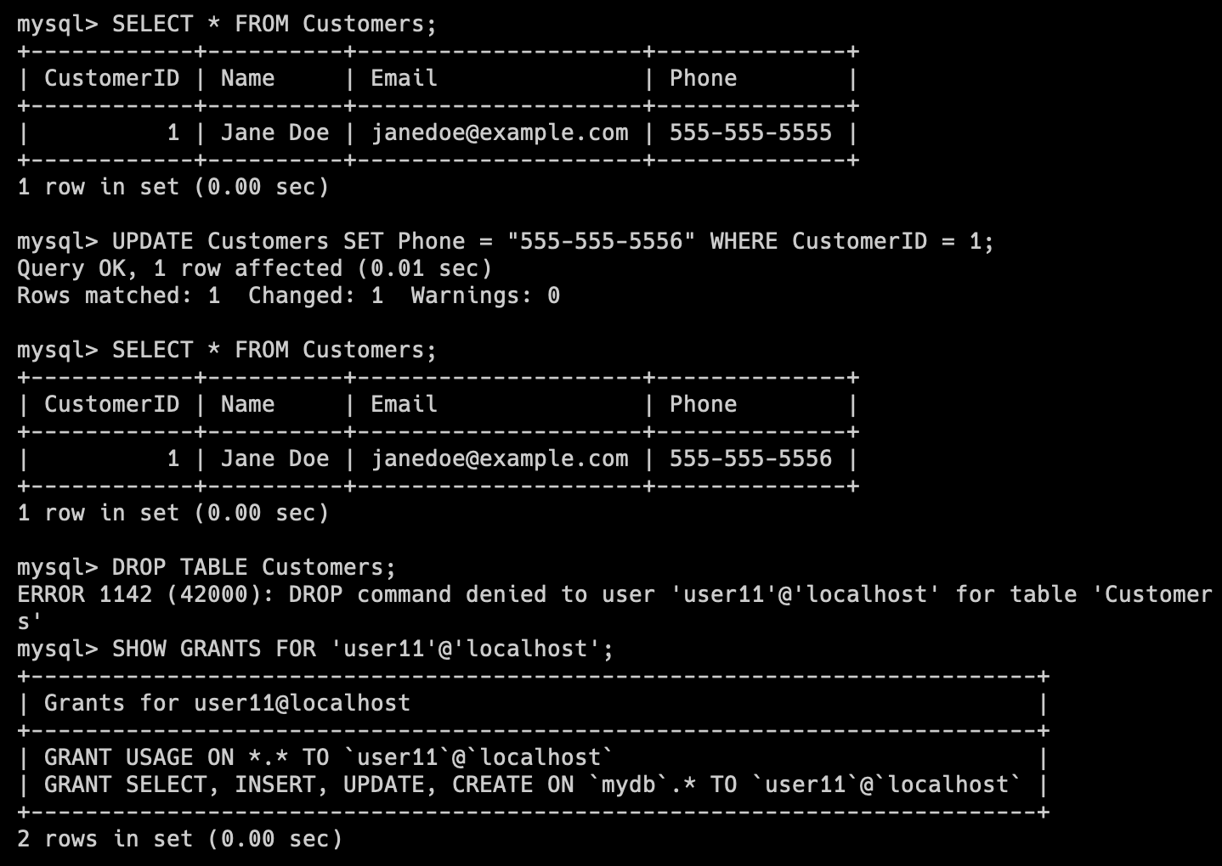

**9. Make a selection from the main table DB MySQL.**

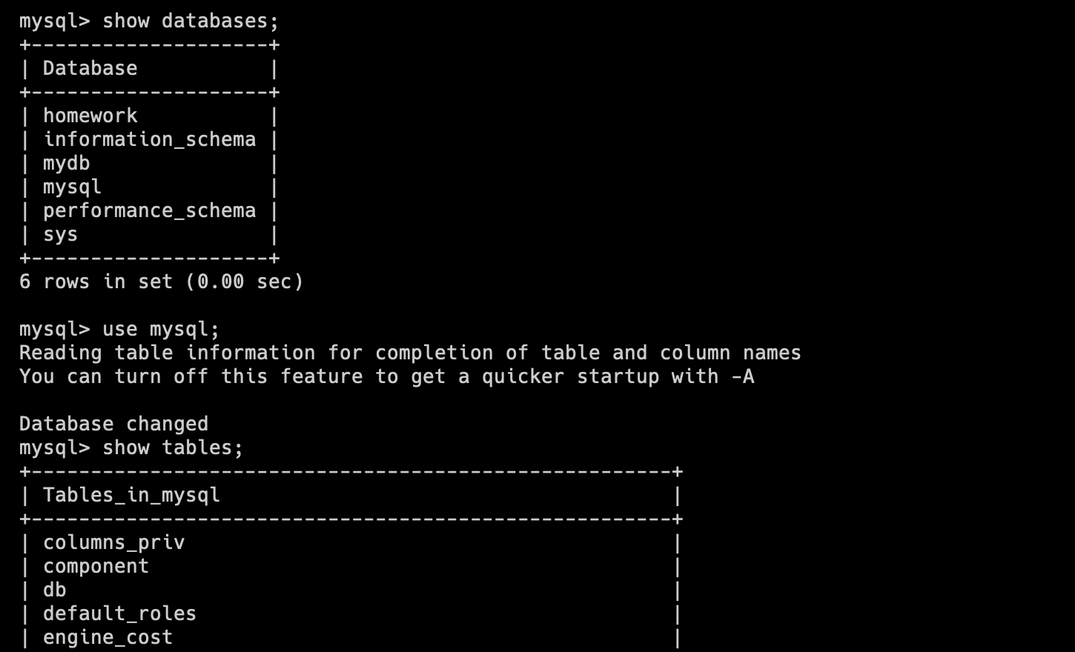

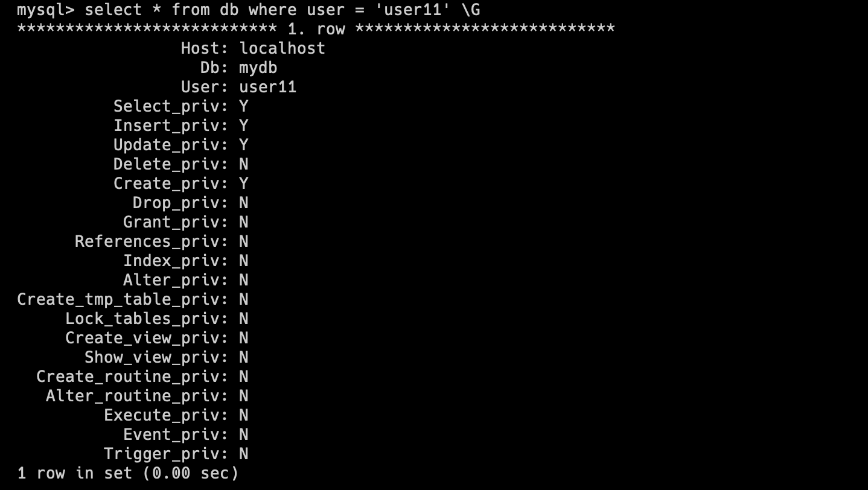

**PART 2**

**10.Make backup of your database.**

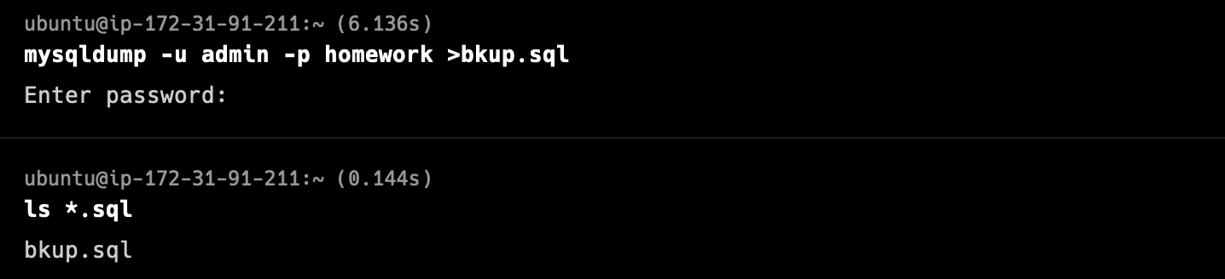

**11.Delete the table and/or part of the data in the table.**

Here are our tables in homework database. Let`s delete one.

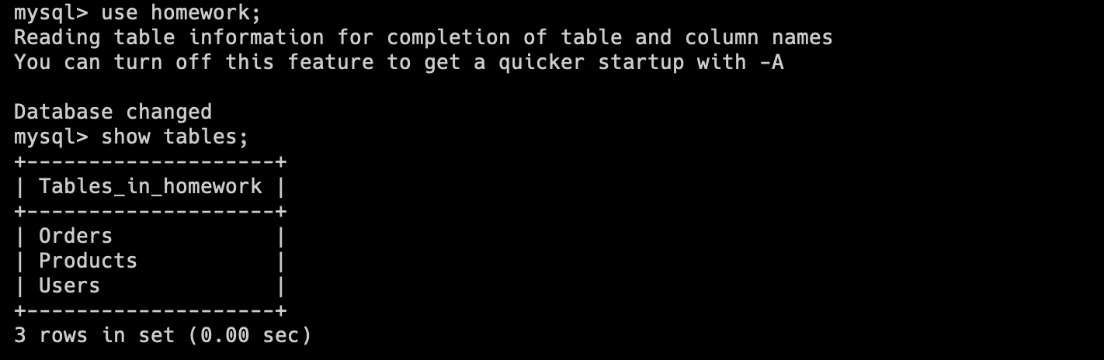

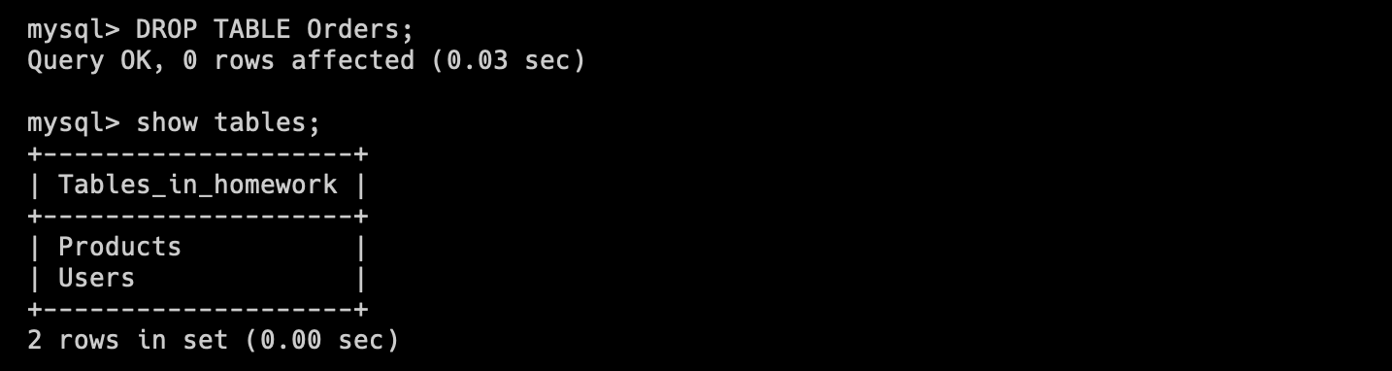

**12.Restore your database.**

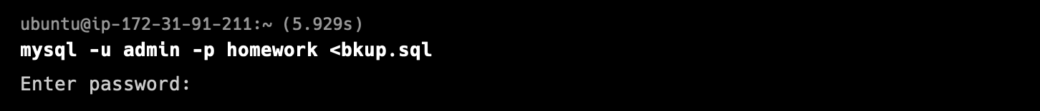

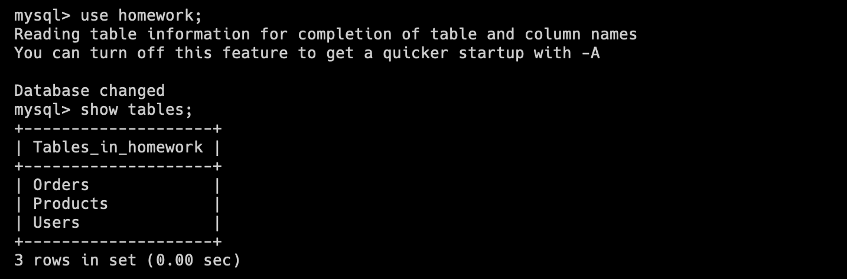

**13.Transfer your local database to RDS AWS.**

First, let`s create a RDS instance.

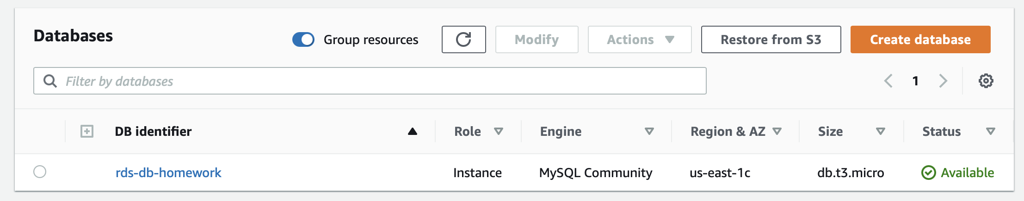

Next we have to create a new MySQL database homework on the RDS instance.

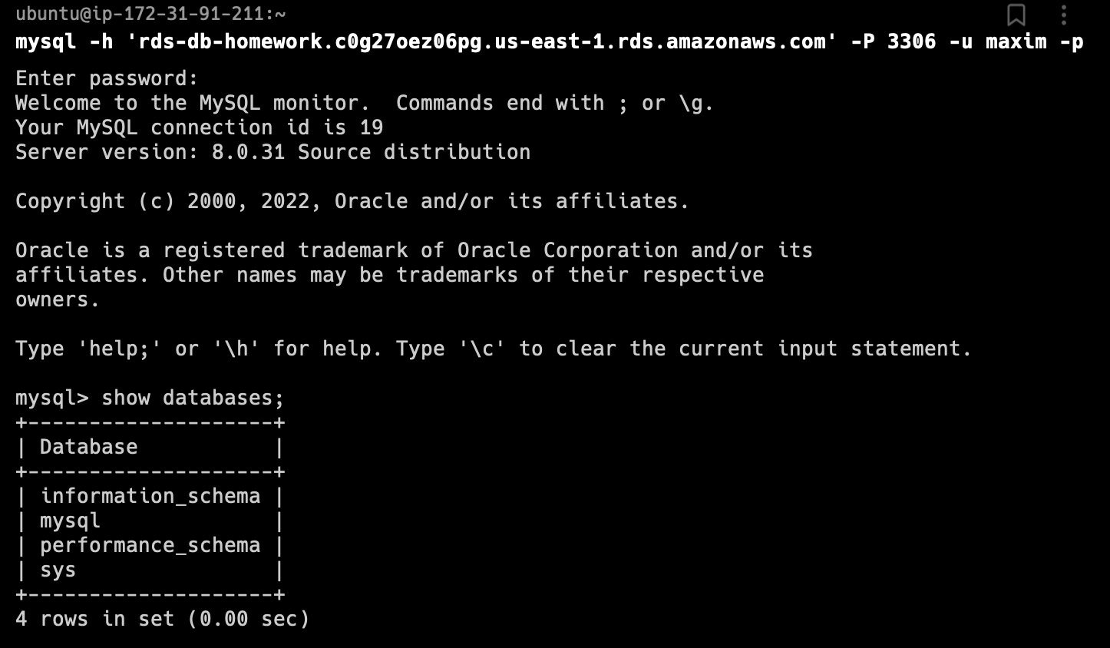

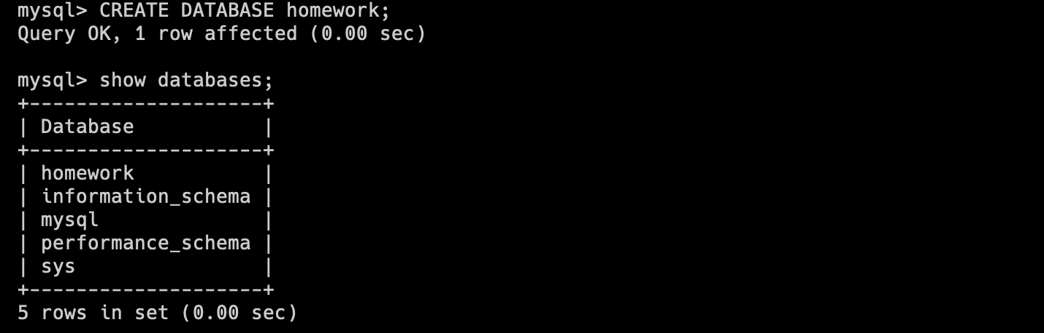

Then create a S3 bucket to copy our bkup.sql from EC2 instance to S3.

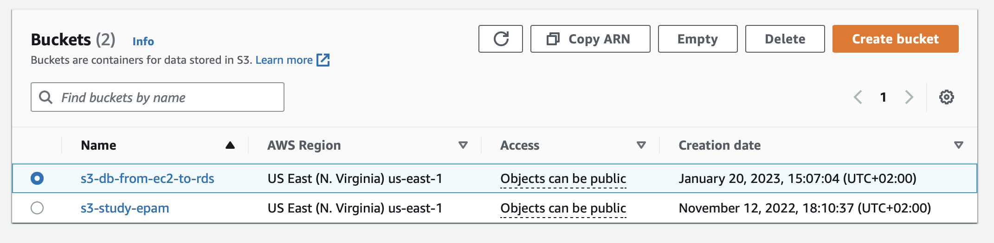

Copy bkup.sql to S3 with the help of AWS CLI installed on our EC2 instance.

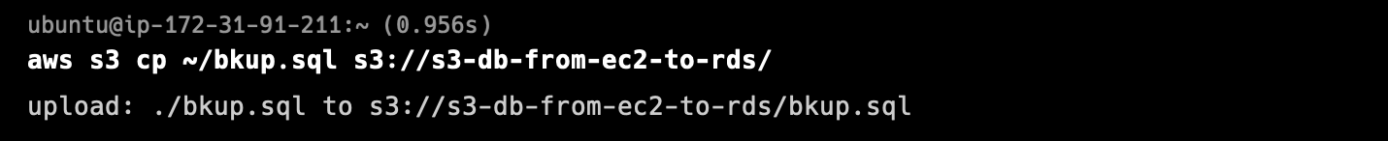

Download the bkup.sql to the local machine.

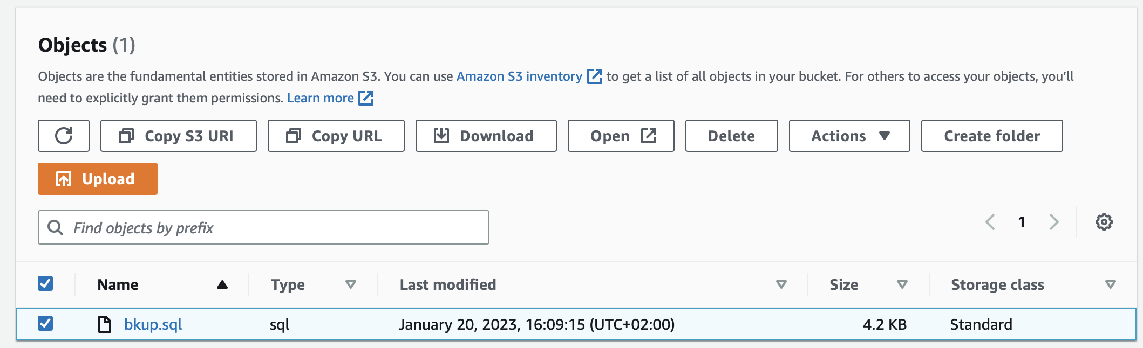

Upload bkup.sql to RDS through the import feature of mySQLWorkbench.

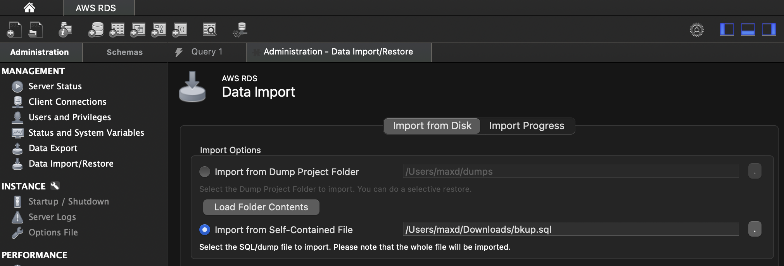

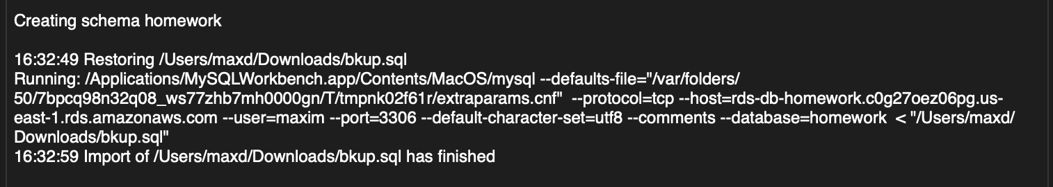

**14.Connect to your database.**

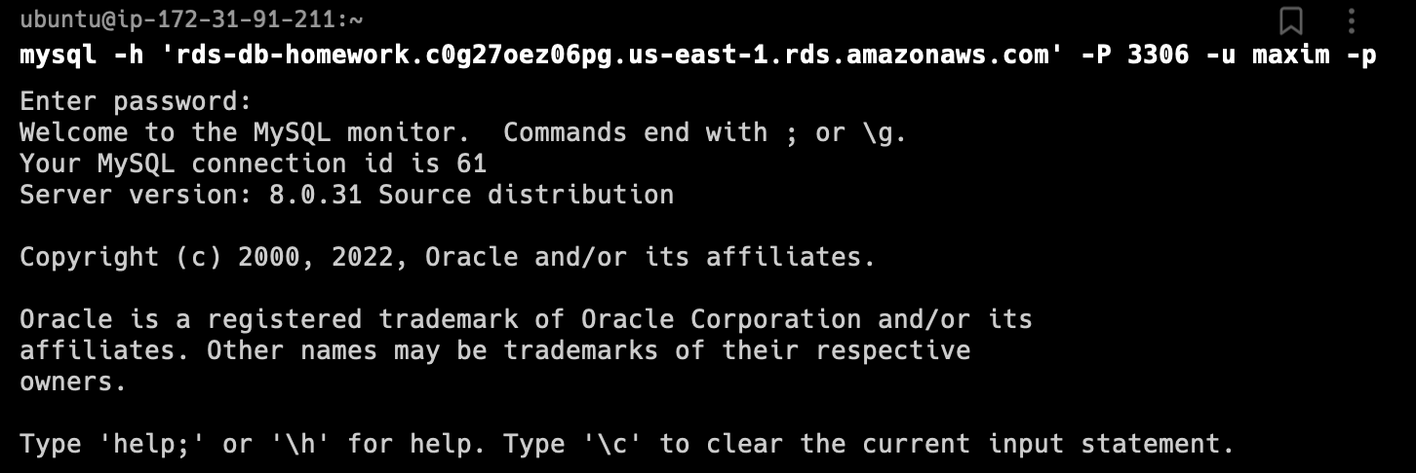

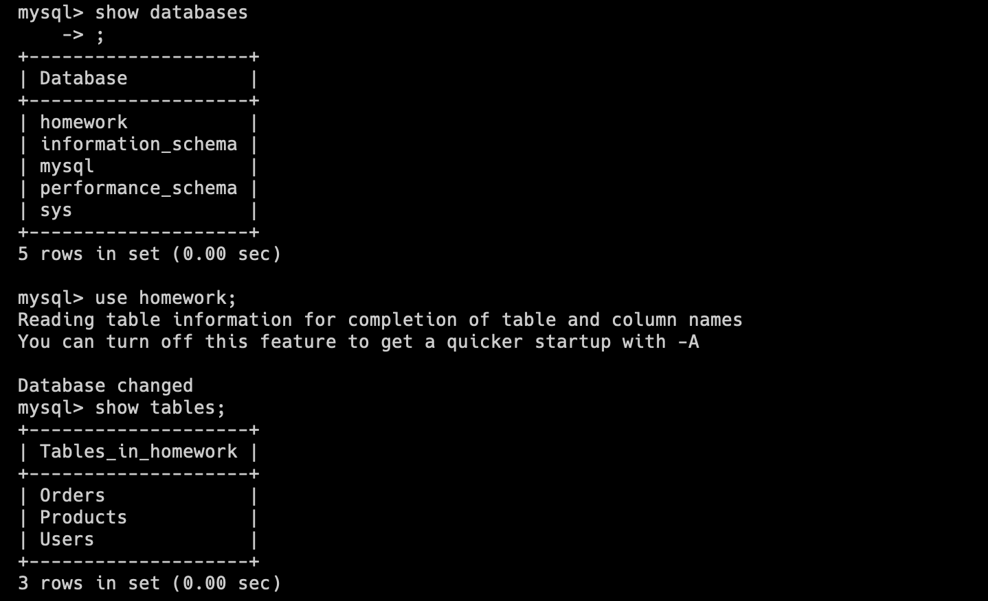

**15.Execute SELECT operator similar step 6.**

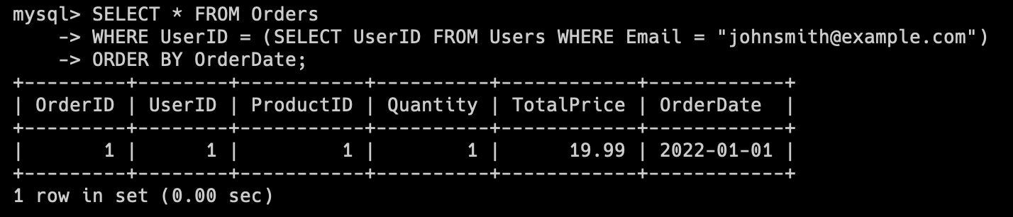

**16.Create the dump of your database.**

The dump of our database we can make through the Snapshot feature in the RDS Console.

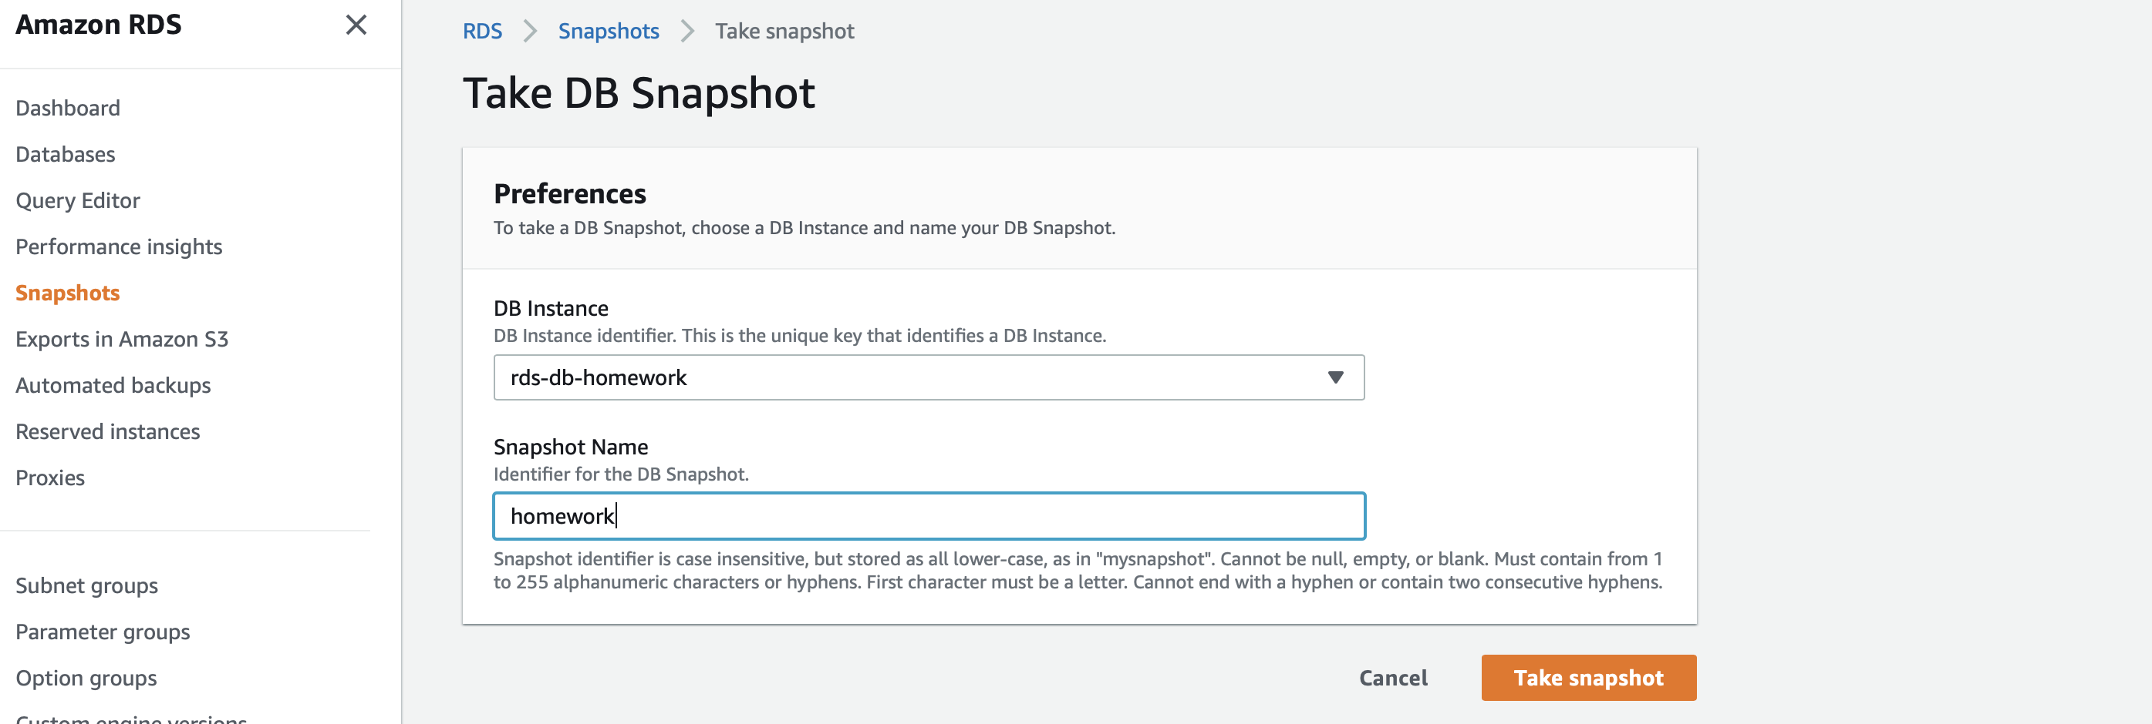

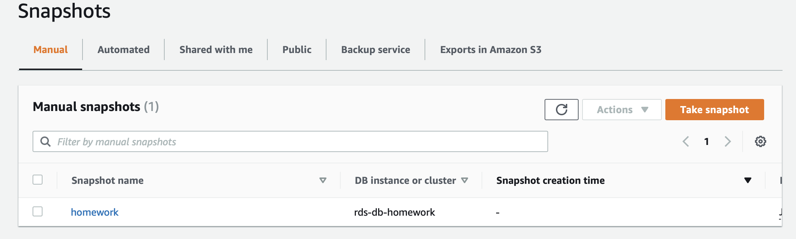

**PART 3 – MongoDB**

**17. Create a database. Use the use command to connect to a new database (If it**

**doesn't exist, Mongo will create it when you write to it).**

Installing MongoDB was a nightmare but I managed to do it))).

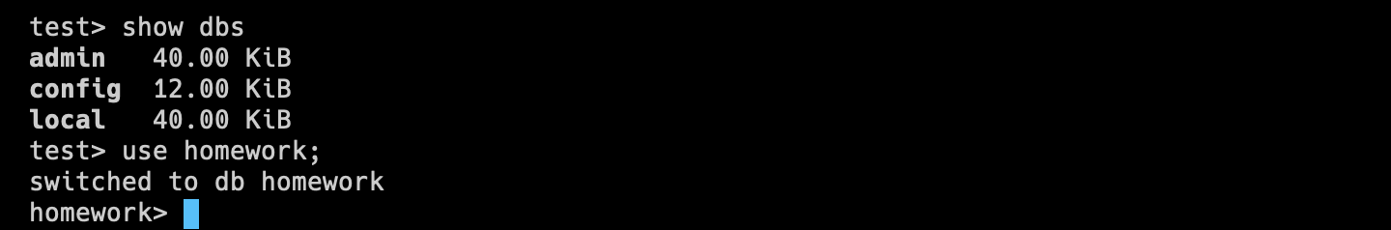

**18. Create a collection. Use db.createCollection to create a collection. I'll leave the**

**subject up to you. Run show dbs and show collections to view your database and**

**collections.**



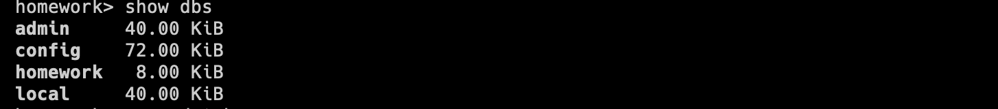



**19. Create some documents. Insert a couple of documents into your collection. I'll**

**leave the subject matter up to you, perhaps cars or hats.**

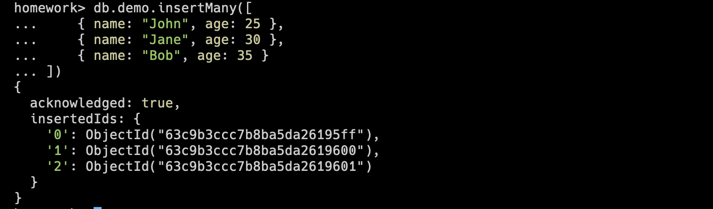

**20. Use find() to list documents out**

